AI vs. Human: Data-Driven Prediction Model for Brain Stroke
Grace Sohn

Personal Statement
My experience at Bridgewater State University as an international student marks a significant milestone in stepping into a broader world. In Korea, there is a saying, “a frog in a well”, used to describe someone who has never experienced the world beyond their surroundings. For much of my life, I thought I was far from being that frog. Born in South Korea, spending my early childhood in Japan, moving to Ghana when I was eight, and attending boarding school in Kenya from middle through high school, I grew up traveling across countries and continents. Doing school in English while speaking Korean at home was a part of my daily life. My friends came from all over the world, and each one of us brought our cultures, languages, and perspectives into our interactions. The experience of growing up in such a diverse and interconnected community shaped who I am today. Because of that, I assumed there would be little new in going to college in America. However, studying and living here was a remarkable and eye-opening experience, revealing so many opportunities and helping me discover new sides of myself.
Starting my undergraduate program in Computer Science, I was given the privilege of getting my first on-campus job as a Mathematics Tutor at the Academic Achievement Center. As a student driven by passion and opportunity, I later served as a Peer Academic Leader in both mathematics and computer science. These roles not only sharpened my technical skills and but also taught me one of the most meaningful lessons of my American experience: the value of co-operative work. Through the teaching experiences over the past two semesters, I was reminded again of the importance of community and connection, creating growth not just for one individual, but for everyone. This re-emphasis provided deeper meaning and motivation for my own academic journey.
I have always found mathematics to be fascinating, and as a Computer Science major with a minor in Statistics, I have developed a strong interest in Data Science and Analytics. Through my coursework, involving Data Structures & Algorithms, Statistical Methods I&II, and Data Visualization, I gained a deeper understanding of how to combine skills in programming and statistics. I learned how to formulate research questions, sort datasets, construct and evaluate models, and do data-driven analysis using various coding software and algorithms.
I am particularly excited about incorporating the use of AI tools into this research. As AI usage continues to grow and expand rapidly across daily and professional tasks, I became very interested in its capabilities. Lately, I have been so fascinated by the natural language processing ability and analytical efficiency of AI chats. Observing the fast-evolving technology of generative AI, I was inspired to explore how these technologies can be applied in data analysis.
For me, ATP research is an extension of my commitment to strengthening and serving my community, especially at the intersection of Computer Science and Statistics. If granted this opportunity, I look forward to applying theories to practice in order to draw conclusions and address a real-world issue. I see this experience as a foundation for my aspirations in research where I can continue to learn, grow, and contribute with purpose.

Title
AI vs. Human: Data-Driven Prediction Model for Brain Stroke

Research Goal
The goal of this research project is to compare an AI-driven analysis and a manual human-computed analysis that each produces a prediction model of brain stroke occurrence based on different demographic and clinical factors. By doing so, we aim to compare the outcomes, accuracy, precision, and other attributes of the two predictions to draw the best conclusion on the factors that contribute to brain stroke.
Abstract
Brain Stroke is a medical condition that is immensely time sensitive. The survivability of the patient depends heavily on immediate treatment after the condition develops, which is not guaranteed all the time. This creates a need for prevention and pre-treatment ahead of time. To achieve this, we raise questions like “What factors or characteristics contribute significantly to brain stroke?” and “How can we predict the likelihood of brain stroke based on those factors?” In this research, I aim to answer these questions using two different analysis methods: 1) Human-computed Statistical Analysis and 2) AI-driven Data Analysis. Using both methods. I will produce logistic regression models and predictions through machine learning techniques to identify significant risk factors, which can help clinical decisions. Furthermore, this research highlights the strengths and weaknesses of each approach, adding more insight into using AI for statistical analysis.

Introduction
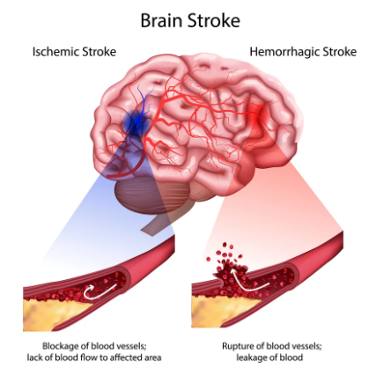
Richard Nixon, Charlie Chaplin, Queen Victoria, Jessie J, and Tedy Bruschi; these names may sound familiar in our memories. But what brings them altogether? Surprisingly, all these people have suffered brain strokes, some of them being survivors while others were not. People from various backgrounds, occupations, ages, and health statuses, can be vulnerable to having brain stroke.
A cerebrovascular accident, commonly known as brain stroke, is a medical condition caused by insufficient blood supply to a part of the brain. This is often caused by a rupture (hemorrhagic) or blockage (ischemic) in blood vessels that restrict blood flow, which can cut oxygen and glucose supply that is crucial to neuron (brain cell) activity. As a result, neurons and brain tissues start to lose functionality and die out within a couple of minutes due to extreme deprivation of nutrients and oxygen, which poses a need for quick treatment and diagnosis. Failure to provide timely treatments can lead to unrestorable disabilities and in worst case, death. According to World Health Organization, brain stroke was “the third leading cause of death and disability globally, with an estimated 93.8 million cases.” The risk of stroke has heightened in the past decade, with “1 in 4 adults predicted to experience a stroke in their lifetime.” These numbers and rates project how serious and critical brain stroke is, drawing global health concerns. This places significant weight on studies and efforts to improve chances of survival and recovery from brain stroke through timely diagnosis, appropriate treatments, and prevention strategies.
The effort toward brain stroke prevention leads us to the next question: what factors or attributes indicate brain stroke, and can we predict whether a patient will have brain stroke based on the patient’s attributes? To perform this, I will use Machine Learning technology in my analysis. According to a stroke data analysis from Journal of Stroke and Cerebrovascular Diseases, a machine learning study “has achieved the highest 99.30% accuracy in stroke diagnosis” with other trials recording above 90% accuracy as well. This brings attention to the potential of machine learning technology in maximizing accuracy of prediction results, which led me to incorporate machine learning as one of my approaches. Additionally, I aim to test whether AI run machine learning predictions can reduce the time consumed on overall analytical processes, improving efficiency and aiding my research.
The dataset that I will be using for this research is a subset of an original Electronic Health Record (EHR) controlled by McKinsey & Company, which is posted on Kaggle as Brain Stroke Prediction Data. The dataset consists of 11 patient attributes and 4982 observations, the number of surveyed patients. The attributes taken from each patient include gender, age, hypertension, heart disease, marriage status, work type, residence, average glucose level, Body Mass Index (BMI), smoking status, and stroke occurrence. These patient attributes will be used as variables for constructing the logistic regression model, where stroke occurrence is the response, and the rest are explanatory variables. Analyzing these demographic and clinical factors to see which ones have statistically significant relations with brain stroke is at the core of this research. The outcomes of this research can help clinics and medical institutions to analyze patient data and perform more effective and efficient diagnoses.

Methodology
The overarching theme of this research focuses on comparative analytical studies of two distinct approaches that are used for investigating brain stroke factors. The study involves human-computed statistical analysis and AI data analysis on the same datasets to ensure that both approaches are directly compared for their interpretability and accuracy of predictions. The analysis methods that I will use in my approaches involve Logistic regression, Decision Tree & Random Forest, Neural Network, and Machine Learning techniques, which will be performed using both manual and AI approaches.
Prior to performing analysis, the dataset containing patient demographic, clinical, and stroke-indicating characteristics will undergo systematic processing to be appropriate for use. Within the pooled data, I will first check for any missing entries for each variable. Once the dataset is cleaned, I will compute descriptive statistics and data distributions to visually examine any noticeable relationships between predictors and stroke occurrences. For categorical variables, I will perform chi-square tests to identify associations that are statistically significant. Data visualization will be performed using Tableau to make a Dashboard that shows variable data distributions.
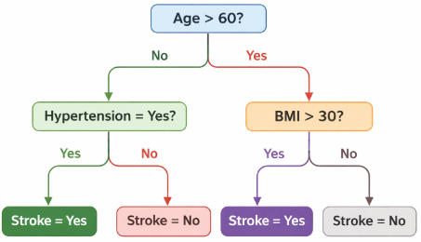
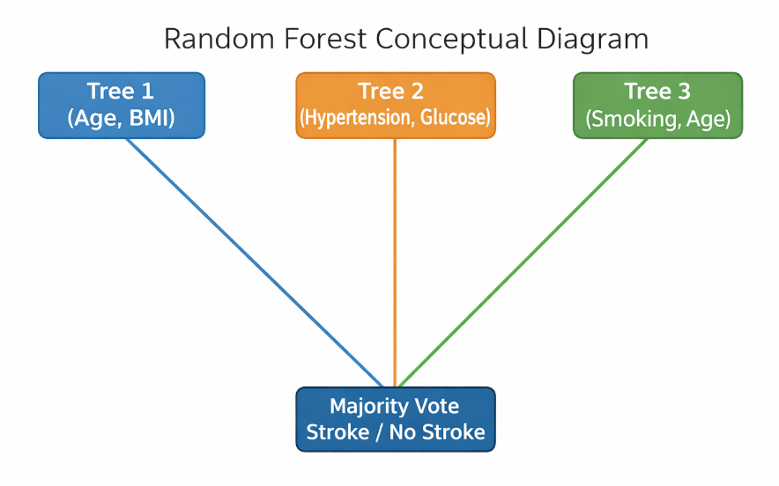
For the human-computed modeling, I will first construct a logistic regression model to estimate the probability of stroke occurrence based on predictors using R and Python. Predictor variables will be selected with reference to their statistical significance observed from the previous descriptive statistics or their clinical relevance. Once the model is built, I will run statistical analyses and hypothesis tests, deep diving into model coefficients. Model performance will be evaluated using accuracy, sensitivity, and specificity. The outcome is expected to show which variables are statistically significant contributors of stroke. Next, I will use machine-learning techniques to do data analysis, involving Decision Tree & Random Forest. To train the trees and networks, I will divide the dataset into two groups: a training group (TR) and a testing group (TS). TR will be used for training the machines, and TS will be used to run the actual test and drive results.
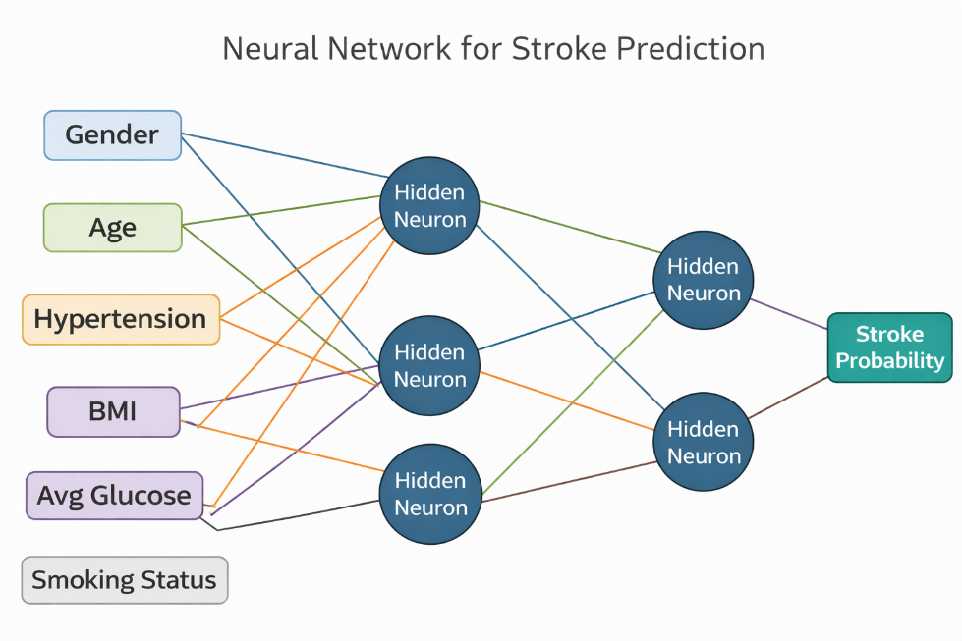
A random forest will be built from a collection of random trees whose results are combined using Python. Next, I will construct a neural network in Python that learns a function of stroke probability. Using the TR dataset, I will train the network to learn how the combination of variables influences stroke probability. The random forest and neural network approaches allow working with many predictors, capturing nonlinear relationships, and producing high predictive accuracy.
For the second part of my research, I will develop predictions using AI to automate logistic regression models and run machine learning algorithms (Random Forest, Neural Network) that were previously constructed in human-driven analysis. An area to explore in the AI-driven approach is prompt engineering, which involves designing inputs for AI models to produce structured and reliable outputs. I will focus on how to design strategic and explicit prompts, set functional requirements, provide data, and verify results using AI tools.
Once both analyses are complete, they will be evaluated and compared using identical scales for performance. This comparative analysis focuses on the two approaches’ predictive performance, interpretability of variables, and clinical relevance. Questions that can be asked include “which variables are identified as statistically significant in both models?", “which are in one but not the other?”
The methodology is designed to identify statistically significant risk factors for brain stroke and to compare the predictive capabilities of traditional statistical modeling and AI-automation. The findings are expected to provide insights into the differences and trade-offs between the two models and how that can further improve healthcare risk modeling.

Bibliography
Agresti, A. (1996). An introduction to categorical data analysis.
Cleveland Clinic. (2025, September 11). What are stroke symptoms? https://my.clevelandclinic.org/health/diseases/5601-stroke
Hilbe, J. M. (2015). Practical guide to logistic regression. Chapman and Hall.
Holland, K. (2025, June 5). Everything you need to know about stroke. Healthline. https://www.healthline.com/health/stroke
Menlanson, J., & Maman, B. (n.d.). The Prompt Engineering Guide. Lecture.
Mike Sevilla, M. (2019, March 5). Increasing stroke awareness: Risk factors, signs & symptoms - dr. Mike Sevilla: Family physician. Dr. Mike Sevilla | Family Physician. https://www.drmikesevilla.com/blog/2019/3/5/increasing-stroke-awareness-risk-factors-signs-amp-symptoms
Sirsat, M. S., Fermé, E., & Câmara, J. (2020). Machine learning for brain stroke: a review. Journal of Stroke and Cerebrovascular Diseases, 29(10), 105162.
World Health Organization. (2025, December 19). Stroke. World Health Organization.
https://www.who.int/news-room/fact-sheets/detail/stroke
VanderPlas, J. (2016). Python data science handbook: Essential tools for working with
data. " O'Reilly Media, Inc.".

Logistics & Timeline
The structure of my research progression is displayed by the timeline below. Each week holds objectives showing what I will do and respective deliverables that I aim to complete. Additionally, I will meet up virtually with my mentor 2-3 times a week to discuss my progress and receive feedback.
Time | Objectives
Week 1 & 2 | - Review clinical books and literature on stroke risk factors as well as machine learning analysis. (40 hours)  - Clean my dataset and study the variables and predictors that my research will focus on. (30 hours)  - Review the AI prompt engineering guide and begin a rough draft on data analysis prompts. (30 hours)
Week 3 | - Finish cleaning and processing my dataset. (10 hours)  - Perform diagnostics and descriptive statistics to examine which variables seem to have strong relations and verify that my data is appropriate for the research. (10 hours)  - Make an interactive Dashboard using Tableau to display histograms, scatterplots, and other data visualizations. (20 hours)
Week 4 & 5 | - Construct a logistic regression model to obtain variables that are statistically significant using R. (20 hours)  - Use Python to run machine learning algorithms to build random trees and neural networks. (60 hours)  - Deliver tables, data visualizations, and interpretations on significant factors. (10 hours)
Week 6-7 | - Use Open AI to produce automated, data-driven pattern discovery (regression and machine learning techniques involved).  (60 hours)  - Evaluate the models to interpret relationships of variables. (20 hours)
Week 8 | - Compare the results of both human and AI data analysis and write a report on my interpretations and conclusions. (40 hours)
Week 9 & 10 | - Write and review a final research paper and data visualizations. (70 hours)  - Design a poster that captures the contents of my research. (10 hours)

Project Budget
Adrian Tinsley Program (ATP) Summer Grant Application
ATP Summer Grants include funds for project expenses: up to $500 for individual projects or $350 per group member (pooled together) for small-group projects. These funds are not released directly to the student but are handled as reimbursements or order requests. The project budget may include supplies, equipment, software, books/texts, photocopies, and/or travel to off-campus research sites (though not for travel to the BSU campus or to meetings with the faculty mentor).
Please list specific project expenses and their costs and explain the purpose of any expenses that might not be obvious to reviewers.

Amount Requested
Supplies & Equipment $___________
Books/Texts $___________
Software $____ChatGPT Subscription ($180.00)_______
Off-campus photocopying $___________
Research-related travel (54.5 cents/mile if driving—not gasoline purchases) $___________
Note that travel to and from campus or to meet with your mentor cannot be reimbursed.
Other (specify) $___________

TOTAL AMOUNT REQUESTED $___180.00____
If your request exceeds the amount provided by the grant, please explain how the remainder will be funded.
